SEM Midterm Spring 2014 Lu Wang
(1)
(1.1)
The mediation model can be instablished as below:
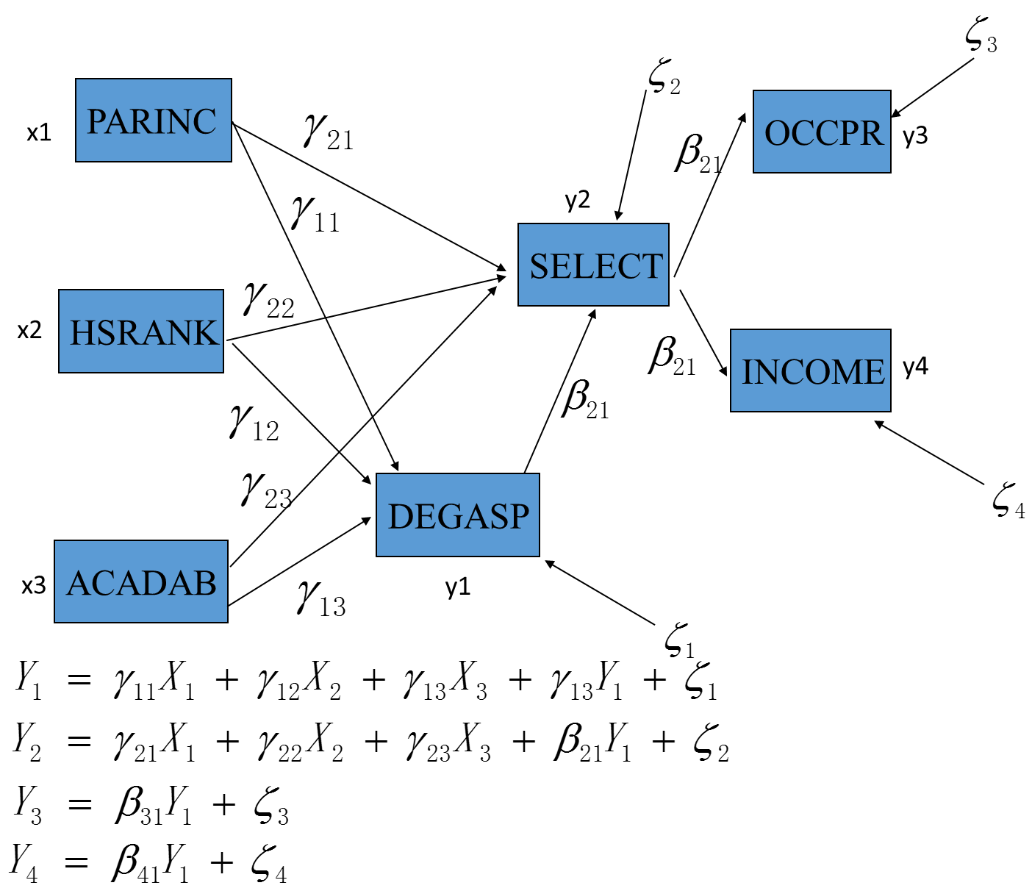
Mplus syntax concerning the model is below:

MODEL:
degasp ON parinc hsrank acadab;
select ON parinc hsrank acadab degasp;
occpr ON select ;
income ON select ;
parinc hsrank acadab with parinc hsrank acadab;
degasp with select@0 occpr@0 income@0;
select with occpr@0 income@0;
occpr with income@0;

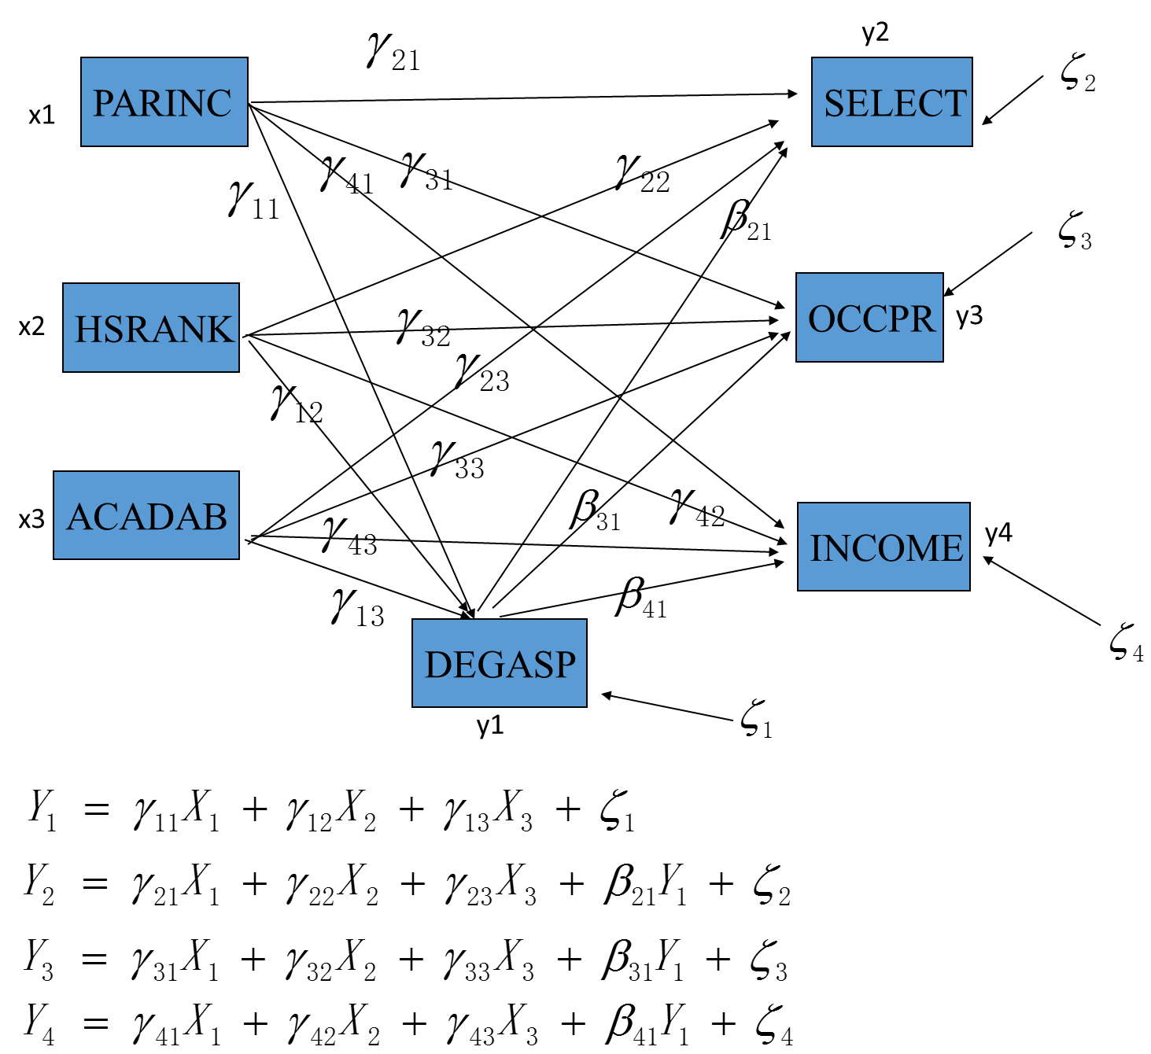
Mplus syntax concerning the model is below:

MODEL: degasp ON parinc hsrank acadab;
select ON parinc hsrank acadab degasp;
occpr ON parinc hsrank acadab degasp ;
income ON parinc hsrank acadab degasp ;
parinc hsrank acadab with parinc hsrank acadab;
degasp with select@0 occpr@0 income@0;
select with occpr@0 income@0;
occpr with income@0;

(1.2)
A)

The model is not a good fit. Reasons as below.
From the following table:
Chi-Square Test of Model Fit

Value 138.452
Degrees of Freedom 9
P-Value 0.0000
Chi-square=138.452, pvalue<0.001

RMSEA (Root Mean Square Error Of Approximation)

Estimate 0.068
90 Percent C.I. 0.058 0.078
Probability RMSEA <= .05 0.001

From RMSEA table, 90 percent CI does not include 0.05, indicating not good fit.
CFI=0.904<0.95, also indicates not good fit.

And to improve the fit of the model, need ot relax the constraint OCCPR WITH SELECT to be freely estimated. The reason for this is from the model modifacation indices output below:

M.I. E.P.C. Std E.P.C. StdYX E.P.C.
ON Statements

DEGASP ON OCCPR 13.569 0.041 0.041 0.065
SELECT ON OCCPR 52.098 -0.279 -0.279 -0.223
SELECT ON INCOME 12.284 -0.131 -0.131 -0.107
OCCPR ON DEGASP 28.016 0.151 0.151 0.096
OCCPR ON INCOME 49.432 0.122 0.122 0.125
OCCPR ON HSRANK 33.444 0.227 0.227 0.111
OCCPR ON ACADAB 39.984 0.260 0.260 0.122
INCOME ON OCCPR 49.432 0.130 0.130 0.128
INCOME ON PARINC 17.309 0.048 0.048 0.078

WITH Statements

OCCPR WITH DEGASP 13.569 0.102 0.102 0.067
OCCPR WITH SELECT 52.094 -0.689 -0.689 -0.256
INCOME WITH SELECT 12.283 -0.345 -0.345 -0.124
INCOME WITH OCCPR 49.432 0.322 0.322 0.126
PARINC WITH INCOME 14.572 0.300 0.300 0.070
ACADAB WITH OCCPR 13.789 0.068 0.068 0.059

OCCPR WITH SELECT have a large M.I. value of 52.094 and a large EPC value of -0.689， indicating this constraint contributes to the lack of fit significantly.

B)
Yes, there should be direct influence.
The reason for this is from the model modifacation indices output below:

M.I. E.P.C. Std E.P.C. StdYX E.P.C.
DEGASP ON OCCPR 13.569 0.041 0.041 0.065
SELECT ON OCCPR 52.098 -0.279 -0.279 -0.223
SELECT ON INCOME 12.284 -0.131 -0.131 -0.107
OCCPR ON DEGASP 28.016 0.151 0.151 0.096
OCCPR ON INCOME 49.432 0.122 0.122 0.125
OCCPR ON HSRANK 33.444 0.227 0.227 0.111
OCCPR ON ACADAB 39.984 0.260 0.260 0.122
INCOME ON OCCPR 49.432 0.130 0.130 0.128
INCOME ON PARINC 17.309 0.048 0.048 0.078

Larger M.I. value indicates there should be direct relationship. The strongest relationship to OCCPR is ACADAB, with M.I. value of 39.984 and EPC of 0.260, and for INCOME, the strongest relationship is PARING, with a M.I value of 17.309 and EPC of 0.048.

(1.3)
A)

The model is a fair fit. Reasons as below.
From the following table:
Chi-Square Test of Model Fit

Value 65.594
Degrees of Freedom 3
P-Value 0.0000
Chi-square=65.594, pvalue<0.001

RMSEA (Root Mean Square Error Of Approximation)

Estimate 0.082
90 Percent C.I. 0.066 0.100
Probability RMSEA <= .05 0.001

From RMSEA table, 90 percent CI does not include 0.05, indicating not good fit.
CFI=0.954>0.95, indicates good fit. So overall, this is a fair fit.

And to improve the fit of the model, need ot relax the constraint INCOME WITH OCCPR. The reason for this is from the model modifacation indices output below:

M.I. E.P.C. Std E.P.C. StdYX E.P.C.
ON Statements

SELECT ON OCCPR 15.138 0.077 0.077 0.062
OCCPR ON SELECT 15.137 0.064 0.064 0.079
OCCPR ON INCOME 48.321 0.120 0.120 0.123
INCOME ON OCCPR 48.320 0.130 0.130 0.127

WITH Statements

OCCPR WITH SELECT 15.138 0.187 0.187 0.070
INCOME WITH OCCPR 48.321 0.315 0.315 0.125

INCOME WITH OCCPR have a large M.I. value of 48.321 and a large EPC value of 0.315

B)
From the model modifacation indices output below:

M.I. E.P.C. Std E.P.C. StdYX E.P.C.
ON Statements

SELECT ON OCCPR 15.138 0.077 0.077 0.062
OCCPR ON SELECT 15.137 0.064 0.064 0.079
OCCPR ON INCOME 48.321 0.120 0.120 0.123
INCOME ON OCCPR 48.320 0.130 0.130 0.127

WITH Statements

OCCPR WITH SELECT 15.138 0.187 0.187 0.070
INCOME WITH OCCPR 48.321 0.315 0.315 0.125

Larger M.I. value indicates there should be direct relationship. So there should be direct relationship of OCCPR ON INCOME and INCOME ON OCCPR. This means there is a reciprocal causation between INCOME and OCCPR. And INCOME with OCCPR should be relaxed too for the same reason.

From the order condition. P=4,p-1=3, so at least 3 variables are excluded, meaning at most 4 variables in each equation. The equations for the new model are below:
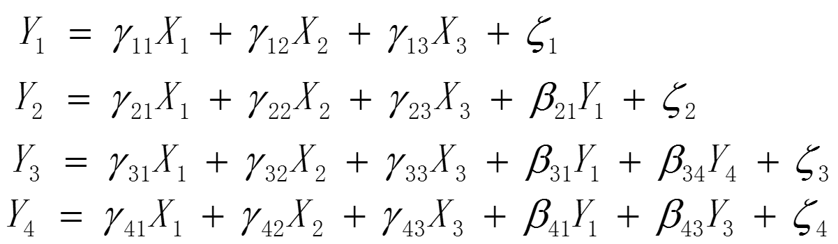
This is not satisfied for Y2-Y4 equations, as a result ,the model is not identified.

(1.4)
? Your explanation should include: some discussion of the path coefficient estimates (raw and standardized), some discussion of direct and indirect effects, some discussion of omitted paths, and some discussion of the limitations of the analysis. Your explanation should refer to actual results of the analyses, but you need not provide an exhaustive discussion of the results. Discuss those features that you feel are most important.

First, we need to talk about the difference of path coefficient in path analysis and regression analysis. As you are familiar with, in regression the coefficient is the change in Y if change 1 unit of the corresponding variable. It has nothing to do with the causality. But in path analysis, the coefficient means the changes in Y in if we manipulate the change in the corresponding variable. So this will tell you the change is from causality. But this does not hold in observational data.

So for the Mediation model, we have DEGASP mediating the effect of PARINC, HSRANK and ACADAB on SELECT and PARINC, HSRANK, ACADAB and DEGASP are have indirect effect on OCCPR and INCOME through SELECT.

SELECT ON
PARINC 0.179 0.012 15.184 0.000
HSRANK 0.613 0.046 13.388 0.000
ACADAB 0.548 0.049 11.241 0.000
DEGASP 0.187 0.031 5.927 0.000

HSRANK and ACADAB have strong effect on SELECT, but when you standardized the data

SELECT ON
PARINC 0.239 0.015 15.517 0.000
HSRANK 0.239 0.018 13.636 0.000
ACADAB 0.205 0.018 11.388 0.000
DEGASP 0.095 0.016 5.945 0.000

The effect of PARINC is also strong. The reason it did not show up is probably because the the magnitude of PARINC. And by Standardization, we can get rid of that effect.

When we look at the normalized residuals
Normalized Residuals for Covariances/Correlations/Residual Correlations
DEGASP SELECT OCCPR INCOME PARINC
________ ________ ________ ________ ________
DEGASP 0.000
SELECT 0.000 -0.001
OCCPR 5.068 0.000 0.000
INCOME 0.510 0.000 6.864 0.000
PARINC 0.000 0.000 0.754 3.950 0.000
HSRANK 0.000 0.000 5.242 0.526 0.000
ACADAB 0.000 0.000 5.698 1.983 0.000

There are some big residuals involing OCCPR, indicating there are likely paths omitted with that variable.

So for the Background model, we have DEGASP mediating the effect of PARINC, HSRANK and ACADAB on SELECT, OCCPR and INCOME.

SELECT ON
PARINC 0.179 0.012 15.183 0.000
HSRANK 0.613 0.046 13.388 0.000
ACADAB 0.548 0.049 11.241 0.000
DEGASP 0.187 0.031 5.927 0.000

HSRANK and ACADAB have strong effect on SELECT, but when you standardized the data

SELECT ON
PARINC 0.239 0.015 15.517 0.000
HSRANK 0.239 0.018 13.636 0.000
ACADAB 0.205 0.018 11.388 0.000
DEGASP 0.095 0.016 5.945 0.000

The effect of PARINC is also strong. The reason it did not show up is probably because the the magnitude of PARINC. And by Standardization, we can get rid of that effect.

INCOME ON
PARINC 0.052 0.011 4.691 0.000
HSRANK 0.019 0.043 0.443 0.658
ACADAB 0.099 0.046 2.164 0.030
DEGASP 0.006 0.030 0.211 0.833

And from this table, we can see the effect of HSRANK, ACDAB and DEGASP on INCOME is pretty small and ttest pval are >0.01, which indicates there might be no effect for those variables.

When we look at the normalized residuals

Normalized Residuals for Covariances/Correlations/Residual Correlations
DEGASP SELECT OCCPR INCOME PARINC
________ ________ ________ ________ ________
DEGASP 0.000
SELECT 0.000 0.000
OCCPR 0.000 3.244 0.000
INCOME 0.000 1.523 6.707 0.000
PARINC 0.000 0.000 0.000 0.000 0.000
HSRANK 0.000 0.000 0.000 0.000 0.000
ACADAB 0.000 0.000 0.000 -0.001 0.000

There are still some big residuals involing OCCPR, indicating there are likely paths omitted with that variable.

And the limitation for both model is that the data is observational data. So they are not manipulated, as a result, we were never really able to conclude a caucation for the variables.

2)
A)
Describe the variables being analyzed, and the source of the data (i.e., the sample). Also describe the factor models used by the researchers, and the theoretical basis for these models in the context of the study. Why are these models of interest to the researchers?

The sample consists of 3956 people at a training program in a firm, compromising white, African- American Hispanic men and women. And data was from the actual recruitment process.

Ther are six variables being analysed. DATVB is a Diffential Aptitude Test that measures the level of understanding and using verbally expression relationship. TCHRG is a variable that measures reading comprehension items describing technical information. DATNU is a test that measures the level to understand and manipulate quantitative information. INDMA is a test called Industrial Math, which measures the ability dealing with arithmetic problems encountered in the job. EASSV is a survey subtest called space visualization that relate to relationship among blocks in diagram. FLWIN is used to stimulate the color blocks that appears in techinal books used in the job.

The first factor model is shown in the figure below. There are three factors: Verbal Reasoning, Numerical Ability and Spatial Visualization. Verbal Reasoning loads on to DATVB and TCHRG. Numerical Ability loads on to DATNU and INDMA. Spatial Visualization loads on to EASSV and FLWIN.
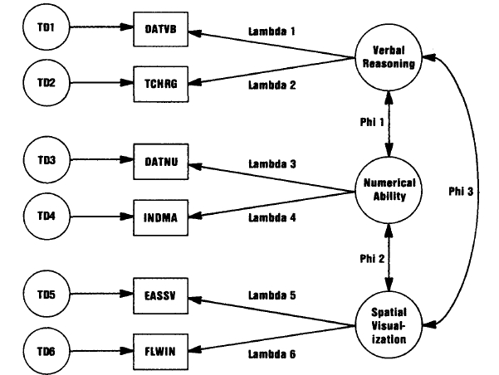
The reasoning for this model is because they designed the variables to be a measurement of the factor, which means they think the variables will directly reflect the factor level.
The reason that research is interested in this model is that firm wants to recuit new workers and they want to evaluate their qualification of different aspects. As a result, they would want to use different tests as a reflection of those factors that they are interested in.

The second model restricts lambda1= lambda2, lambda3= lambda4, lambda5= lambda6. The reason that the research is interested in this is there may be some case that they want to take the two variables in each factor with equal importance.

The third model is nested within second model. Other than the restrictions above. TD in each factor group is also restricted to be equal.

B)
Here I used three factors and model is described as below:

F1 BY DATVB@1 TCHRG INDMA FLWIN;
F2 by DATNU@1 TCHRG INDMA FLWIN;
F3 by EASSV@1 TCHRG INDMA FLWIN;
f1@1 f2@1 f3@1;

And from the identification rule:
First, for 3 common factors, a total 9 parameter constraints are needed to identify the model.
In the above model, there are 6+3 constraints.
Second, one nonzero loading or factor variance must appear for each factor.
All factor variance restricted to 1.
So the model is identified.

Mplus output is followed.

MODEL FIT INFORMATION

Number of Free Parameters 18

Loglikelihood

H0 Value -27612.317
H1 Value -27515.777

Information Criteria

Akaike (AIC) 55260.633
Bayesian (BIC) 55373.727
Sample-Size Adjusted BIC 55316.531
(n* = (n + 2) / 24)

Chi-Square Test of Model Fit

Value 193.079
Degrees of Freedom 3
P-Value 0.0000

RMSEA (Root Mean Square Error Of Approximation)

Estimate 0.127
90 Percent C.I. 0.112 0.142
Probability RMSEA <= .05 0.000

CFI/TLI

CFI 0.985
TLI 0.923

Chi-Square Test of Model Fit for the Baseline Model

Value 12322.295
Degrees of Freedom 15
P-Value 0.0000

SRMR (Standardized Root Mean Square Residual)

Value 0.136
From the above model fit information. Chi-square is 193.079, df=3, pval<0.001. RMSEA confidence interval is 0.112~0.142, indicating poor fit. CFI=0.985, indicating good fit. And SRMR=0.136>0.05, indicating poor fit.

From the local fit information:

F2 BY
TCHRG -0.075 0.038 -2.010 0.044
FLWIN 0.062 0.030 2.071 0.038

F3 BY
TCHRG 0.002 0.017 0.107 0.915

There are three variables did not fit well.

Standardized Residuals (z-scores) for Covariances/Correlations/Residual Corr
DATVB DATNU EASSV TCHRG INDMA
________ ________ ________ ________ ________
DATVB -12.934
DATNU -14.725 -47.280
EASSV -19.698 999.000 999.000
TCHRG -13.034 -19.651 -38.434 -25.408
INDMA -17.420 -33.633 999.000 -13.768 999.000
FLWIN -13.465 -21.109 -103.047 -28.152 -8.548

From the z-score table, all the residuals are pretty high, indicating bad fit.

So overall, I would rate this as a poor fit.

Residual Variances
DATVB 0.248 0.012 21.052 0.000
DATNU 0.131 0.022 5.891 0.000
EASSV 0.069 0.023 2.979 0.003
TCHRG 0.383 0.013 29.833 0.000
INDMA 0.494 0.013 38.240 0.000
FLWIN 0.338 0.010 34.226 0.000

From the above table, we can get the communality is 1-variance as listed below:

DATVB 0.752
DATNU 0.869
EASSV 0.931
TCHRG 0.617
INDMA 0.506
FLWIN 0.662

F2 WITH
F1 0.837 0.015 56.598 0.000

F3 WITH
F1 0.598 0.016 36.690 0.000
F2 0.573 0.018 32.336 0.000

The three factors also show strong correlation with each other, since they shared lots of variables.

C)
I fit the model as is shown in the graph above, the first model. And replicates their analysis. Mplus output is followed.

Chi-Square Test of Model Fit

Value 104.109
Degrees of Freedom 6
P-Value 0.0000

RMSEA (Root Mean Square Error Of Approximation)

Estimate 0.064
90 Percent C.I. 0.054 0.075
Probability RMSEA <= .05 0.013

CFI/TLI

CFI 0.992
TLI 0.980

Chi-Square Test of Model Fit for the Baseline Model

Value 12322.295
Degrees of Freedom 15
P-Value 0.0000

SRMR (Standardized Root Mean Square Residual)

Value 0.014

From the above analysis concerning the overall fit. Chi-Square value is 104.109, df=6, and pval<0.001. 90% confidence interval is 0.054~0.075, just a fair fit. Not perfect. However, from CFI=0.992, the model is perfectly fit. And SRMR=0.014<0.05, also indicating the model is perfectly fit. So overall and conpare to the last problem, this model is a good fit.

STDYX Standardization

Two-Tailed
Estimate S.E. Est./S.E. P-Value

F1 BY
DATVB 0.869 0.006 135.324 0.000
TCHRG 0.783 0.008 101.971 0.000

F2 BY
DATNU 0.846 0.007 114.607 0.000
INDMA 0.756 0.009 88.102 0.000

F3 BY
EASSV 0.612 0.011 54.629 0.000
FLWIN 0.865 0.008 103.637 0.000

F1 WITH
F2 0.868 0.009 93.246 0.000
F3 0.915 0.010 92.475 0.000

F2 WITH
F3 0.889 0.011 82.672 0.000

The factor loading lambda are all significant. And the three factors are also strongly correlated, which can expected, because people excel in one test is more likely to excel in the other.

Residual Variances
DATVB 0.246 0.011 22.030 0.000
DATNU 0.284 0.013 22.686 0.000
EASSV 0.625 0.014 45.516 0.000
TCHRG 0.387 0.012 32.195 0.000
INDMA 0.428 0.013 32.994 0.000
FLWIN 0.251 0.014 17.367 0.000
From the output, we can calculate the communality as 1- variances, and listed below:
DATVB 0.754
TCHRG 0.716
DATNU 0.375
INDMA 0.613
EASSV 0.572
FLWIN 0.749

And when we look at the communality, DATNU seems to be poorly fit, because only 37.5% of variance is explained from the factor loading. But overall, the model fits well.

And compared with the model in B, all global fit index are better in C than that in B. So the model is a much better fit than B.

